|  |  |
| --- | --- |
| linear IPS | Year 12 Specialist  TEST 1  Friday 8 February 2019  TIME: 45 minutes working  **No Classpads nor calculators** **allowed!**  37 marks 8 Questions |

Name:_______________________________

Teacher: ____________________________

**Note: All part questions worth more than 2 marks require working to obtain full marks.**

Q1 (1 & 2 = 3 marks)

Express each of the following in the form  where  are real numbers.

1. 
2. 

Q2 (3 marks)

Determine the remainder when  is divided by 

Q3 (3 marks)

Determine the complex number  in polar form.

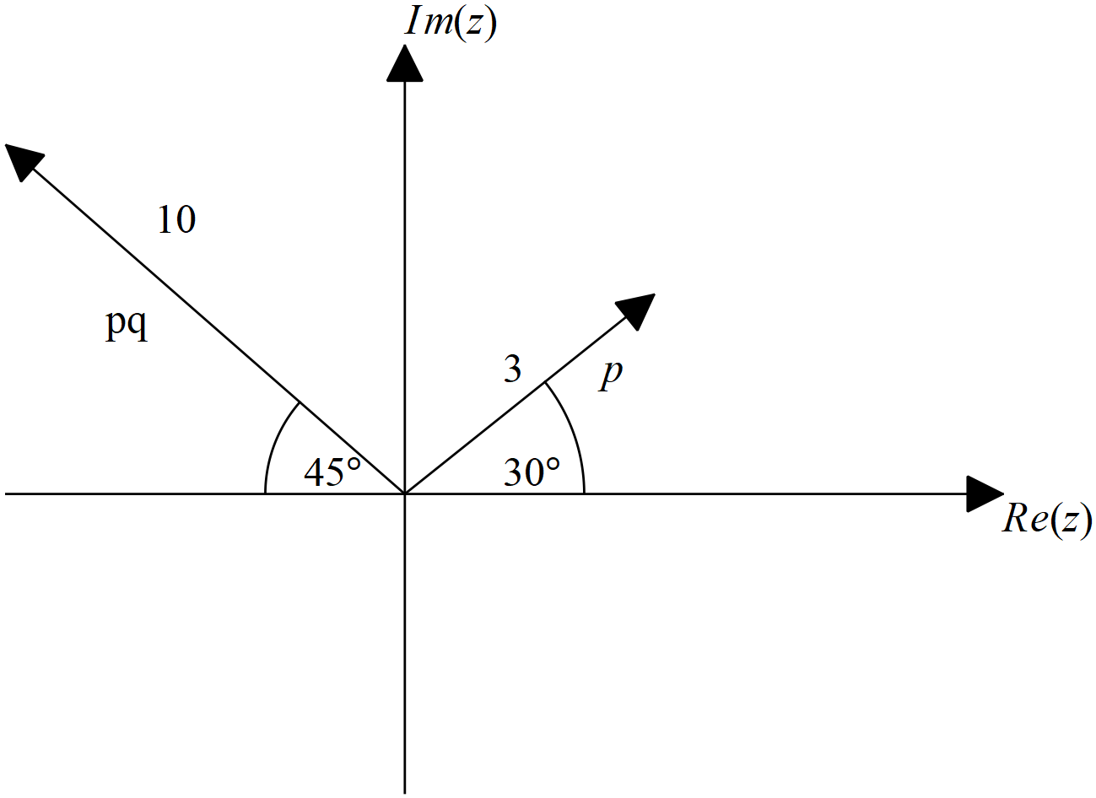

Q4 (2 & 3 = 5 marks)

Sketch the following in the complex plane showing all major features.

1. 

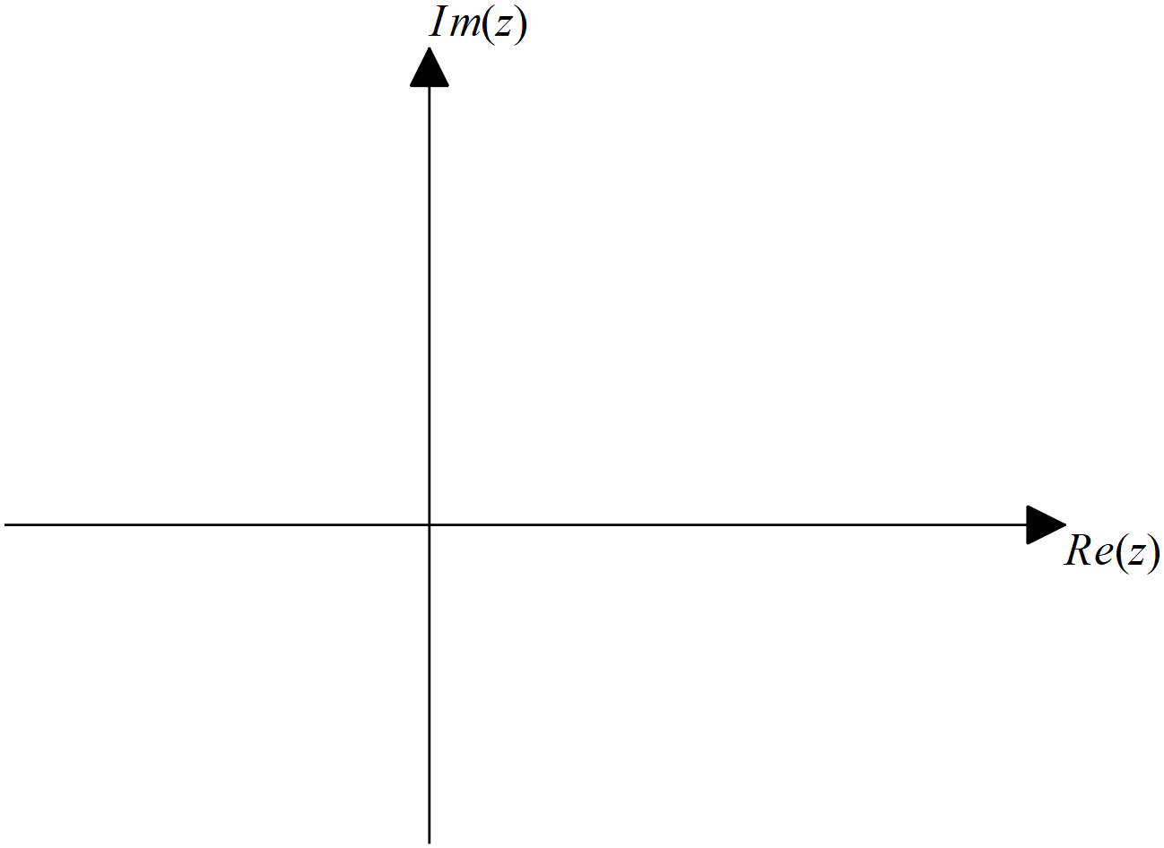

1. 

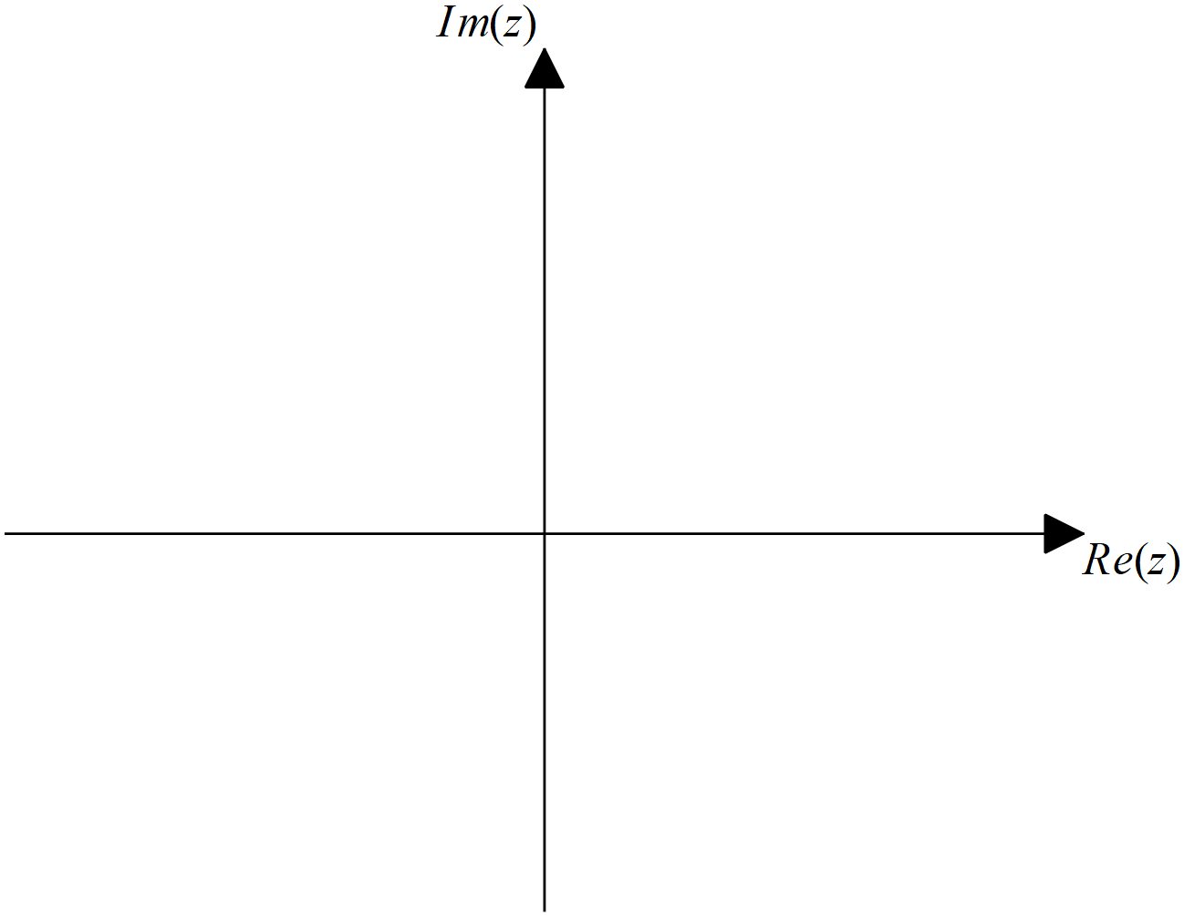

Q5 (2, 3 & 3 = 8 marks)

If  and  where  are real numbers, show the following:

1. 
2. 
3. Hence or otherwise show that if there is a complex root to the quadratic equation  with real coefficients, then the conjugate is also a root.

(Hint: Take the conjugate of both sides of the quadratic equation)

Q6 (4 marks)

Consider the set of complex numbers  that satisfy the following equation:

.

Determine the cartesian equation, in terms of  , of these numbers.

Q7 (2 & 4 = 6 marks)

Consider the function  where  are real constants.

It is known that  is a factor, and  &  .

1. Determine all three factors of .
2. Determine the values of .

Q8 (4 & 1 = 5 marks)

Consider the set of complex numbers, , that satisfy the following:

 ,  a real constant, and .

Determine:

1. The value of  given that the Maximum value of .
2. Maximum value of .